CS 346 - Telecommunications and Networks

**LAB 1 - Ubuntu Installation as Virtualbox Guest OS**

In this lab we will install and use Ubuntu Server 20.04 (A command line linux server) as a guest operating system running on VirtualBox. This will allow us a base environment to experiment with and set-up further networking infrastructure. We chose Ubuntu Server 20.04 as it does not include any resource intensive GUI components, and can be set up easily on a low-tier computer.

**Prerequisites**

You should already have VirtualBox running on your computer.

You can get the latest version of VirtualBox here:

<https://www.virtualbox.org/wiki/Downloads>

**Installing Ubuntu Server**

You can find a Download of Ubuntu Server here:

<http://releases.ubuntu.com/20.04/ubuntu-20.04.1-live-server-amd64.iso>

There are several good tutorials on how to install Ubuntu under VirtualBox. Including, but not limited to:  
<https://www.youtube.com/watch?v=PhErfLCd7OQ>  
  
Or if you do not like video tutorials you can use a text/image based tutorial: (Ubuntu Desktop)  
<https://linuxhint.com/install_ubuntu_virtualbox_2004/>

Finding and being able to follow high quality tutorials is an important skill to master. If you find any tutorials that you find to be useful, please share them with the class.

**NOTE:** Make sure to follow the section about setting your network device into “bridged” mode. This will allow your guest operating system to access the network in the same way your host operating system does. Choose the network card that your computer uses to connect to the network.

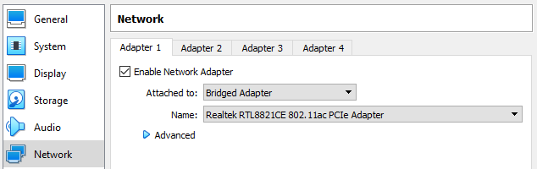

Once Ubuntu Server is running follow the installation prompts. It’s probably easiest to choose the default prompt for everything, however, you can experiment here. Choose different settings, if something doesn’t work you can create a new virtual machine and reinstall Ubuntu in minutes. Here is a video tutorial where these prompts are being followed:

<https://youtu.be/xUH256WAWt0?t=216>

It’s recommended that you choose to “Install OpenSSH Server”. This will allow you to remotely ssh into your server.

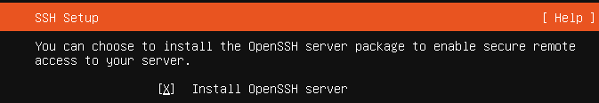

**Using Linux**

Once Ubuntu server is installed you will need to login with the username and password you setup during installation. Here is a cheat sheet demonstrating common Linux commands:  
<https://files.fosswire.com/2007/08/fwunixref.pdf>

<https://phoenixnap.com/kb/wp-content/uploads/2020/02/linux-commands-cheat-sheet-phoenixnap.pdf>

<https://www.linuxtrainingacademy.com/linux-commands-cheat-sheet/>

Pay special attention to the Networking sections of these commands. Now is the time to experiment with them and see what happens. The worst thing you can do is ruin your guest operating system. In that case, you’ll need to reinstall it. This should become very easy to do after messing up a few times.

Try to **ping google.com** and see if you have an internet connection.

**Install Networking tools in Ubuntu Server 20.04**

Ubuntu Server 20.04 does not come with the classic linux networking tools installed. To install these type the following on the command line (Internet Connection needed first):

**sudo apt-get install net-tools**

**Deliverables:**

Once you have Ubuntu Server installed and are logged in, run the following command:

**uname -a > ~/submit_me.txt**

This will create the file *submit_me.txt* with information about your Ubuntu Installation.

Now run the command:

**ifconfig |grep inet >> ~/submit_me.txt**

This will append the file *submit_me.txt* with information about your current network configuration.  
  
You’ll need to read this file (located at ~/submit_me.txt) from the command line. If you don’t know how to read a file on Linux command line there are several popular options.  
  
**Nano** is considered an easy file editor for beginners:

<https://www.howtogeek.com/howto/42980/the-beginners-guide-to-nano-the-linux-command-line-text-editor/>

**EMACS** is a popular file editor with Linux enthusiasts:

<http://www.jesshamrick.com/2012/09/10/absolute-beginners-guide-to-emacs/>  
  
**VIM** is considered a little more daunting to master by most. It requires memorizing keyboard shortcut. It has a sharp learning curve, but becomes a very powerful tool for the experienced developer:  
<https://danielmiessler.com/study/vim/>

It’s a good idea to become familiar with all of these text editors. Often your ideal text editor will not be available on every Linux box you need to work on.

**Submit the contents of this file (*~/submit_me.txt*) to the LAB 1 Submission on Canvas**

**Remember:**

These are only suggested tutorials that should lead you towards the goals of this lab. There are MANY other tutorials out there that will lead you towards the same goals. Take this time and search for a few of them. Compare what you find to the tutorials above. Decide which level of tutorial is best for you.